# **Department of Computer Science and Engineering Islamic University of Technology (IUT)** A subsidiary organ of OIC

# **Lab Report 03**

# CSE 4512 : Computer Networks Lab

## 

## **Name:** Abdullah **Student ID:** 200041126 **Section:** 01 **Semester:** 5th (WINTER) **Academic Year:** 2022-2023

**Date of Submission:** 24-08-2023

### **Title:** Configure router using static routing to connect multiple networks in Cisco Packet Tracer

### **Objectives**:

1. Understand how to operate Cisco Packet Tracer
2. Learn to create and connect multiple networks using static routing
3. Understand wiring of different network components like router, switch, PC etc.
4. Configure router and switch interfaces
5. Verify connectivity of the network
6. Understand the basics of IP Subnetting
7. Learn to subnet a network following given specifications

### **Diagram of the experiment:**

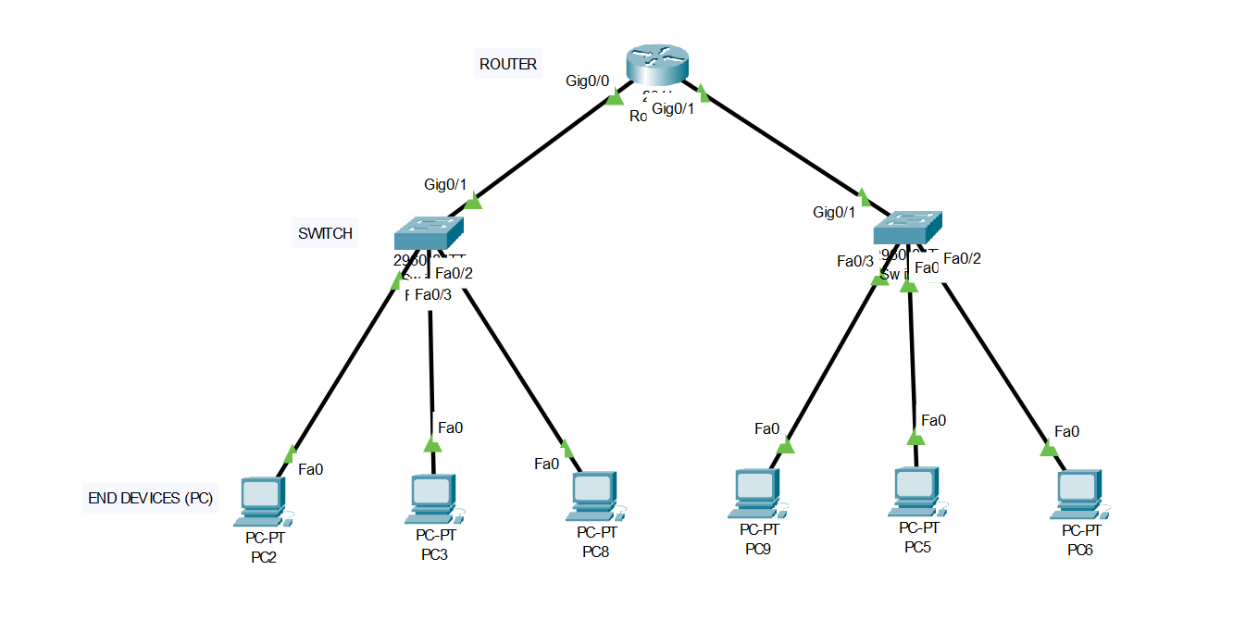

**Fig.** Network Topology

### **Working Procedure:**

**1.** Firstly, to build the topology I needed one router, two switches and six PCs. Then I had to place them accordingly and connect them with straight through wire.

**2.** In the PC’s Desktop tab we configured the IP address as mentioned. As my id is 200041126, I had to use 126 in the third octet of the Ipv4 address. Then we set the Default subnet mask for Class C ip address. And for the Default Gateway we use the first valid host of that network.

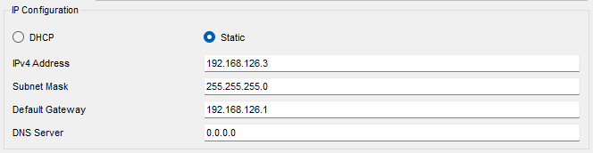

**Fig.** Configuring PCs

**3.** Then I had to configure the router in its CLI. The commands used for the setting are-



**Fig.** Initiating Configure



**Fig.** First Switch Configure



**Fig.** Second Switch Configure

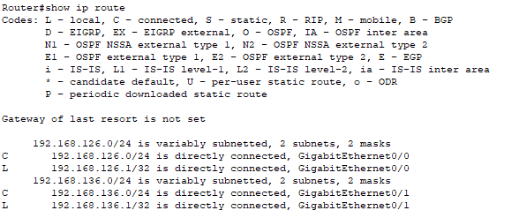

**Fig.** Showing IP Route

**4.** After setting up the proper connections we need to check if its working or not. For that we need to ping a pc of one another from a pc of different network (192.168.126.2 to 192.168.136.3) and we get the response-

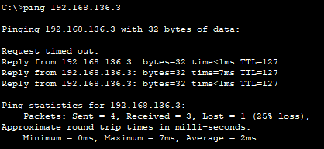

**Fig.** Checking the connection

Here we can see that the first packet was not delivered because the router’s routing table was still not updated properly then. But later on all the packets were delivered.

### **Questions (Answer to the point)**:

**Q1.** **Write the command to check the status of all interfaces in a router.**

**Ans:** The command is- “show ip interface brief”

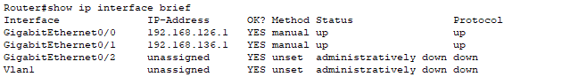

**Q2. Why do we use switches and not hubs?**

**Ans:** Hubs simply broadcast incoming data to all devices on network that leads to unnecessary network traffic on the other hand, switch use MAC address to forward data to destination port only. Moreover, Switches are used as they provide better performance, efficiency, security and scalability.

**Q3.** **How do you make all the configuration changes in a cisco device persistent? What would happen if you don’t do this?**

**Ans:** We make all the configuration changes persistent with the command “copy running-config startup-config”. And if we don’t do it then we will lose all the configurations after a reboot.

**Q4. What are the interfaces of the router? Why are they necessary?**

**Ans:** Interfaces on a router means the connection points to other devices and network. Some interfaces are Ethernet, WAN, USB, VLAN etc. interfaces. They are necessary for establishing connectivity between different types of networks, devices, communication technologies and they enable data to flow between local networks, remote networks and the internet while providing necessary control and configuration options to manage network traffic.

**Q5. Why is default gateway necessary?**

**Ans:** Default gateway is necessary because it is an essential setting that consists of the IP address of the router responsible for routing traffic between the local subnet and other networks. It is an important concept in networking that enables devices to communicate with destinations beyond their immediate networking boundaries.